**UNIT-V: Electromagnetism and Magnetic Properties of Materials**

Laws of electrostatics, Electric current and the continuity equation, Ampere’s and Faraday’s laws, Maxwell’s equations, Polarisation, Permittivity and Dielectric constant, Internal fields in a solid, Clausius-Mossotti equation, Ferroelectrics and Piezoelectrics. Magnetisation, permeability and susceptibility, Classification of magnetic materials, Ferromagnetism and ferromagnetic domains, Hysteresis, Applications of magnetic materials.

**UNIT-V**

**Electromagnetism and Magnetic Properties of Materials**

**Fundamental laws of Electricity and Magnetism**

To understand Maxwell’s equation, we must go through the basic laws of electricity and magnetism.

1. **Gauss’ law in electrostatics is expressed mathematically as **

i.e. the total normal electric flux over a closed surface is equal to  times the charged enclosed by the surface.

1. **Gauss’ law in Magnetostatics is expressed mathematically as **

i.e. the total normal magnetic flux over a closed surface is always equals to zero. This also signifies that monopoles cannot exist.

iii) **Faraday’s law of Electromagnetism is expressed mathematically as **

i.e., the rate of change of magnetic flux in a closed curve induces an electro motive force (emf) opposes the cause.

**iv) Ampere’s law of Electromagnetism is expressed mathematically as **

i.e., the line integral of magnetic flux in a closed circuit is equal to times the current enclosed by the current loop.

Maxwell modified Ampere’s law by introducing the idea that a changing electric field is a source of magnetic field in a dielectric medium or in vacuum which is equivalent to a conventional current in a conductor. This current is known as displacement current (iD). Now the modified Ampere’s law can be expressed as, . Here the displacement current,, where  is the electric flux.

**Equation of continuity**

Electric current is the rate of flow of charge and is represented in opposite direction. Thus we have  🡪[1]

If *dq* charge is enclosed in volume element *dV* and is leaving a surface having area *ds*, we have,

 and 

Where ***J*** is the current density and ρ is the volume charge density. Therefore eq. [1] becomes



 🡪[2]

Using Gauss divergence theorem on LHS of equation [2], we get,



Therefore equation [2] becomes 

*  🡪[3]

Equation [3] is known as equation of continuity.

**Maxwell’s electromagnetic equations**

Maxwell in 1962 formulated the basic laws of electricity and magnetism from the four fundamental

laws of electromagnetism. These relations are known as Maxwell’s equations.

**Integral form of Maxwell’s equations**

1) 

2)

3)

4)

**Differential form of Maxwell’s equations**

1) 

2) 

3) 

4) 

These Maxwell’s equations are convertible from integral form to differential making use of Gauss’ divergence theorem and Stokes’ theorem.

**Equation of Electromagnetic waves**

Applying Maxwell’s electromagnetic equations to a homogeneous and isotropic dielectric medium having μ and ε as permeability and permittivity and which offers infinite resistance to the current, thus J=0 and ρ=0, then,

 🡪[1a]

 🡪[1b]

 🡪[1c]

 🡪[1d]

Taking curl of equation [1c] we get,







 🡪[2a]

Similarly by taking the curl of equation [1d] we get  🡪[2b]

The general wave equation is given by, 

Comparing equations [2a] and [2b] with the general wave equation, the velocity of the electromagnetic wave in a medium as 

In free space electromagnetic waves travel with a speed of , equal to velocity of light.

**DIELECTRIC PROPERTIES**

**Introduction:** Dielectrics are insulating materials of high specific resistance, negative temperature coefficient of resistance and large dielectric strength. In insulators, all the electrons are bound to their parent molecules and there are no free charges. Even with normal voltage or thermal energy, electrons are not released. But in dielectrics there exists the movement of electrons at high temperatures, causing a small flow of current. Dielectrics are called as poor conductors of electricity and good conductors of heat energy.

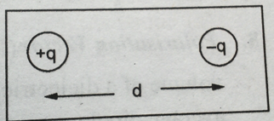**Electric Dipole:**

A system consisting of two equal and opposite charges separated

by a distance is called electric dipole.

**Dipole moment:** The product of charge and distance between two charges is called dipole moment. i e, = q x r

*Units:*Coulomb -meter .

**Permittivity:** It is a quantity, which represents the dielectric property of a medium. Permittivity of a medium indicates the easily polarisable nature of the material.

*Example:- For vacuum or free space,*ε 0 = 8.85x10-12 F/m.

*Units:* Faraday / Meter or Coulomb / Newton-meter.

**Dielectric constant*:*** The dielectric characteristics are determined by the dielectric constant. The dielectric constant or relative permittivity of a medium is defined as the ratio between the permittivity of the medium to the permittivity of the free space.

ε r = ε / ε 0 = C / C 0

where, ε is permittivity of the medium , ε 0  is permittivity of the free space ,C is the capacitance of the capacitor with dielectric and C 0  is the capacitance of the capacitor without dielectric.

*Units:* No Units.

**Capacitance*:*** The property of a conductor or system of conductors that describes its ability to store electric charge.

C = q / V = ε A / d

Where, C is capacitance of capacitor,q is charge on the capacitor plate , V is potential difference between plates , A is area of capacitor plate ε is permittivity of medium and d is distance between capacitor plates.

*Units:*Farad.

**Polarization:**

The process of producing electric dipoles which are oriented along the field direction is called polarization in dielectrics.

**Polarizability (α ) :**When the strength of the electric field E is increased the strength of the induced dipole μ also increases . Thus the induced dipole moment is proportional to the intensity of the electric field.

i.e., E **= α E** , where α is polarizability. It can be defined as induced dipole moment per unit electric field.

i.e., **α = / E**

*Units:* Farad meter2

**Polarization Vector ( ) :** The dipole moment per unit volume of the dielectric material is called polarization vector P. If is the average dipole moment per molecule and N is the number of molecules per unit volume, then

polarization vector ,**= N**

*Units: Coulomb/m2*

The dipole moment per unit volume of the solid is the sum of all the individual dipole moments within that volume and is called the polarization of the solid.

**Electric Flux Density or Electric Displacement ():**The number of lines of forces received by unit area is calledthe Electric Flux Density orElectric Displacement.

i.e., =

*Units:Coulomb/m2*

**Relation between P and εr :**

The Electric Flux Density orElectric Displacementat a point in the material is given by, D =εrε0 E -------------(1)

Where, E is electric field strength,εris relative permittivity of materialand ε 0  is permittivity of free space

As polarization measures additional flux density arising from the presence of the material as compared to free space, it has same units as D.

Hence **D = ε0  E + P** -----------(2)

Since D = ε0 εr E

ε0 εr E = ε0  E + P

P = ε0 εr E - ε0  E

**P = ε 0(ε r - 1 ) E.**

**Electric Susceptibility ( χe ) :**When a ielectric is paced in an electric field (E), then polarization takes place.The polarization vector P is proportional to the electric fieldE. i.e., P

Therefore, the polarization vector can be written as,**P = ε 0 χe E**

**Relation between χe and εr :**

Therefore χe = P / ε0  E = ε0(εr - 1 ) E / ε0  E

**χe = (ε r - 1 )**

**Dielectric Strength:**It can be defined as the minimum voltage required for producing dielectric breakdown. Dielectric strength decreases with raising the temperature, electric field, humidity and age of the material.

**\*\*\*Polarization Methods:**

polarization occurs due to several atomic mechanisms. When a specimen is placed in a d.c. electric field, polarization is due to four types of processes.

They are

1. Electronic polarization

2. Ionic polarization

3. Orientation polarization and

4. Space charge polarization

**\*\*\*1. Electronic Polarization:-**

When electric field is applied on a dielectric material then all the positive nuclei of atoms move in the field direction and the entire negative electron clouds of atoms move in opposite direction, hence dipoles will be formed. This phenomenon is known as electronic polarization.

**Derivation:**

Consider an atom placed inside an electric field. The centre of positive charge is displaced along the applied field direction while the centre of negative charge is displaced in the opposite direction, thus a dipole is produced. The displacement of the positively charged nucleus and the negative electrons of an atom in opposite directions, on application of an electric field, result in electronic polarization.

Consider the nucleus of charge ‘ Ze ‘ is surrounded by an electron cloud of charge ‘ -Ze ‘ distributed in a sphere of radius R.

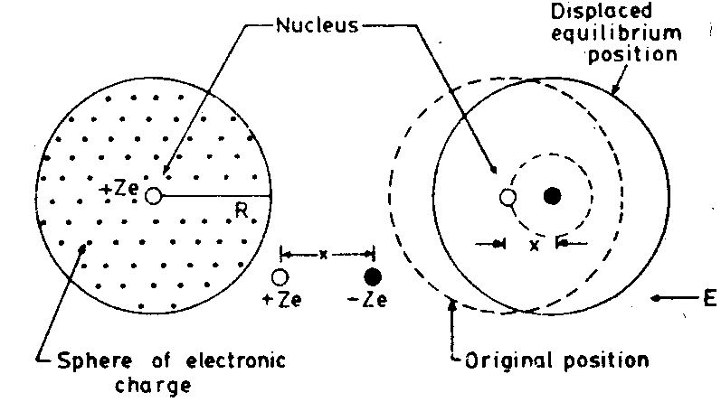

Charge density of electrons ‘ρ’ is given by,

ρ = -Ze / ( 4/3ΠR3 ) = - (3/4) (Ze / ΠR3 ) ----------(1)

When an external field of intensity E is applied, the nucleus and electrons experiences Lorentz forces in opposite direction. Hence the nucleus and electron cloud are pulled apart.

Then Coulomb force develops between them, which tends to oppose the displacement. When Lorentz and coulomb forces are equal and opposite, equilibrium is reached.

Let ‘ x ‘ be the displacement

Lorentz force = -Ze . E ---------- (1) ( since = charge . applied field )

Coulomb force = Ze . [ charge enclosed in sphere of radius ‘x’ / 4 Π ε 0 x2 ]

Charge enclosed = ( 4 / 3 ) Π x3 ρ

= ( 4 / 3 ) Π x3 [( - 3 / 4 ) ( Z e / Π R3 ) ]

= - Z e x3 / R3

Therefore Coulomb force = ( Ze ) . ( - Z e x3 / R3 ) / 4 Π ε 0 x2 = - Z2 e2 x / 4 Π ε 0 R3  -------- (2)

At equilibrium, Lorentz force = Coulomb force

i.e., equation(1) = equation(2)

-Ze . E = - Z2 e2 x / 4 Π ε 0 R3

⇒E = -Ze x / 4 Π ε 0 R3

Or x = 4 Π ε 0 R3 E / Ze

Thus, displacement of electron cloud is proportional to applied field.

The two charges +Ze and -Ze are separated by a distance ‘x‘ under applied field constituting induced electric dipoles .

*Electronic dipole moment* ***( μe):-***

Induced dipole moment μe = Ze . x

μe = Ze . (4 Π ε 0 R3 E / Ze ) = 4 Π ε 0 R3 E

Therefore,**μe =  = 4 Π ε 0 R3E**

*ElectronicPolarizability****(αe ) :-***We know that, μe  α E , μe  = αe. E

⇒αe = μe / E = 4 Π ε 0 R3 E / E

Therefore,**αe = 4 Π ε 0 R3**.

***Also,***Pe = ε0 E (εr - 1 ) and P = N αe E

Therefore,ε0 E (εr - 1 )= N αe E

⇒εr - 1 = N αe / ε0

Hence,**αe = ε0  (εr - 1 ) / N .**

*Electronic Polarization* **(Pe) :-**

The dipole moment per unit volume is called electronic polarization. It is independent of temperature.

Pe = N

Pe = N . (4 Πε0 R3 E )

**Pe= 4 Πε0 R3 N E**, where R is radius of atom

*Electric Susceptibility***(χe ) :-**

Electric Susceptibility, χe = P / ε 0 E

χe =4 Πε0 R3 N E / ε 0 E

Therefore,**χe = 4 Π R3 N**

**\*\*\*2.Ionic Polarization:-**

When electric field is applied on an ionic dielectric material then all the positive ions move in the field direction where as the negative ions move in opposite direction, hence dipoles will be formed. This phenomenon is known as ionic polarization.

Consider a NaCl molecule. Suppose an electric field is applied in the positive direction. The positive ion moves by x1 and the negative ion moves by x2 as shown in fig.2

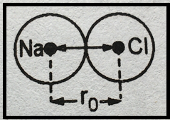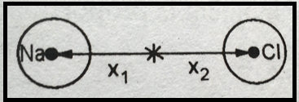

*Fig.1 In the absence of electric field Fig.2 In the presence of electric field*

Let M is mass of positive ion, M is mass of negative ion

x1 is displacement of positive ion

x2 is displacement of negative ion

Total displacement x = x1 + x2 --------------(1)

Lorentz force on positive ion = + e E ----------(2)

Lorentz force on negative ion = - e E ----------(3)

Restoring force on positive ion = -k1 x1----------(2 a)

Restoring force on negative ion = +k2 x2----------(3 a) where k1, k2 Restoring force constants

At equilibrium, Lorentz force and restoring force are equal and opposite, then

For positive ion, e E = k1  x1

For negative ion, e E = k2 x2] ---------- (4)

Where k1 = M ω02 & k2 = m ω02  where ω0 is angular velocity of ions

Therefore x = x1 + x2 = ( e E / ω02 ) [ 1/M + 1/m ] ------------(5)

*Ionic dipole moment* ***( μi):-***

Induced dipole moment μi= charge . distance of separation

i.e., μi = e . x = e. ( e E / ω02 ) [ 1/M + 1/m ]

**μi= ( e2 E / ω02 ). [ 1/M + 1/m ]** ------------(6)

*IonicPolarizability****(αi ) :-***

We know that, μi α E , μi = αi. E

⇒αi = μi / E = ( e2 E / ω02 ). [ 1/M + 1/m ] / E

Therefore,**αi = ( e2 / ω02 ) .[ 1/M + 1/m ]**

This is ionic polarizability.

*Electronic Polarization* **(Pi) :-**The dipole moment per unit volume is called electronic polarization.

Pi = N

**Pe= N . ( e2 E / ω02 ). [ 1/M + 1/m ]**

**3.Orientation (or) Dipolar Polarization:-**

When electric field is applied on a polar dielectric material then all the dipoles tend to rotate in the field direction, hence dipole moment increases enormously. This phenomenon is known as orientation (or) dipolar polarization.

In methane molecule, the centre of negative and positive charges coincides, so that there is no permanent dipole moment. On the other hand, in certain molecules such as CH3Cl, the positive and negative charges do not coincide .Even in the absence of an electric field, this molecule carries a dipole moment, they tend to align themselves in the direction of applied field. The polarization due to such alignment is called orientation polarization. It is dependent on temperature. With increase of temperature the thermal energy tends to randomize the alignment.

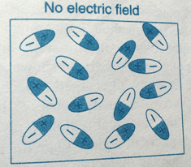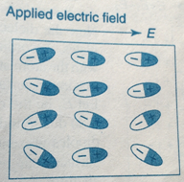

*Fig.1 In the absence of electric field Fig.2 In the presence of electric field*

*Orientation dipole moment* ***( μO):-***

***μO =* µ2 . E / 3kB T**

Where, µ = total dipole moment of ions, E = applied electric field

= Boltz mann’s constant, T= absolute temperature.

*Orientational polarizability* ***(αo ):-***

We know that, μo α E , μo = αo. E

⇒αo = μo / E =µ2 . E / 3kB T .E

⇒**αo = µ2 / 3kB T**

Thus, orientational polarizability α0 is inversely proportional to absolute temperature of material.

*Electronic Polarization* **(Pe) :-**

Orientation(or) Dipolar polarization, Po = N

Po = N **µ2 . E / 3kB T**

**4. Space charge Polarization:-**

It occurs due to diffusion of ions along the field direction and giving rise to redistribution of charges in the dielectrics.

Without the application of external field, the ions are orderly arranged as shown in above fig.d1. When the field is applied, the ions diffuse with respect to the direction of applied field asshown in above fig.d2.

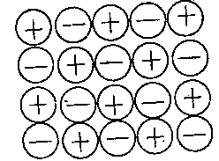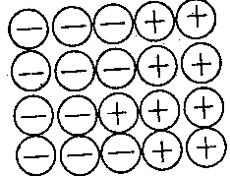

*Fig.1 In the absence of electric field Fig.2 In the presence of electric field*

Thus the polarization occurs, known as space charge polarization. Normally, this type of polarization occurs in ferrites and semiconductors and will be very small.

**Total Polarizability:-**

Total polarization of a material is , αT**=** αe**+** αi**+** αo **+**αS

**= 4 Π ε 0 R3+**  [ 1/M +1/m ]+

**Total Polarization:-**

Total polarization of a material is , PT = Pe + Pi + PO +PS

= **4 Πε0 R3 N E [ 1/M +1/m ] +**N **µ2 . E / 3kB T**

**\*\*\*\*\* Internal field or Local field or Lorentz field:**

**Definition:**The total electric field acting on an atom inside the polarized dielectric is known as internal field or local field

or Lorentz field.

To find the expression for local field on an atom at point ‘A’ inside the dielectric, this is placed inside the charged

parallel plate capacitor. Now the dielectric is polarized in the electric field across the charged plates. According to Lorentz

method, let us imagine a spherical region with the atom at ‘A’ as the centre so that the spherical region can cover the

maximum surface of polarized dielectric as shown in fig.1.

Let, E1 is electric field due to charge density on plates

E2 is electric field inducedcharges on two sides of dielectric

E3 is electric field due to dipoles present within the spherical region

E4 is electric field due to surface charges on spherical region.

Then, thetotal electric field acting on an atom at point ‘A’ inside the dielectric is given by,

Internalor Local field A = E1 + E2 + E3 + E4 ------- (1)

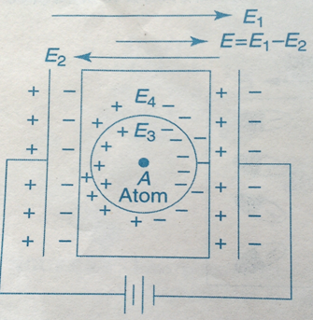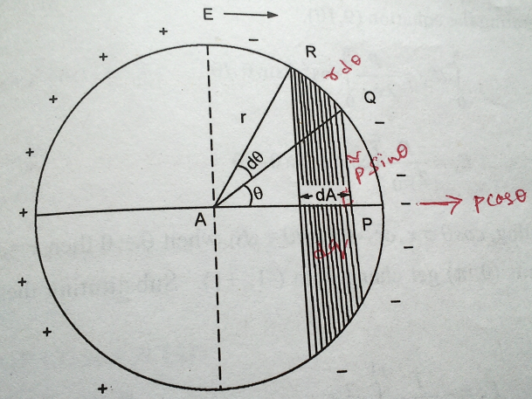

Fig.1. Polarized dielectricin electric field Fig.2. Enlarged view of spherical region

**Field E1 :** E1 is electricfield intensity due to charge density on plates

From the electric field theory,E1 = D / ε 0

but, D = ε 0 E + P

Therefore, E1 = ε 0 E + P / ε 0  = E + P / ε 0  ----------(2)

**Field E2 :** E2 is the electricfield intensity at A due to charge density induced on two sides of dielectric

Therefore E2 = - P / ε 0  -----------(3)

**Field E3 :**For a cubic structure, due to symmetrical distributions of charges within the spherical region,

E3 = 0 ----------- (4)

**Calculation of Field E4 :**

The enlarged view of the spherical region is shown in fig.2. If ‘dA' is the surface area of the sphere of radius ‘ r ’ lying between θ and θ + dθ, where θ is the direction with reference to the direction of applied field, then

dA = 2 Π (PQ). (QR) ------------ (5)

But, sin θ = PQ / r ⇒ PQ = r sin θ

And dθ = QR / r ⇒ QR = r dθ

Hence dA = 2 Π (r sin θ) . (r dθ) = 2 Π r2 sin θ dθ ------------ (6)

The charge ‘ dq ‘ on surface ‘ dA‘ is equal to the normal component of the polarisation multiplied by the surface area.

i.e., dq = dA . P cos θ

dq = 2Π r2 sin θ dθ . P cos θ

dq = P . (2 Π r2 sin θ cos θ dθ )

The field due to this charge dq at A, is denoted by dE4in the directionof E (θ = 0) is obtained by imagining a unit charge at point ‘ A ‘.

Therefore, dE4  = dq .1. cos θ / 4 Πε0 r2

= P. (2 Π r2 sin θ cos θ dθ) . cos θ /4 Πε0 r2

dE4 = P (cos2θsin θdθ) / 2 ε0

dE4 =( P / 2 ε0).cos2θ sin θ dθ ------- (7)

Thus the total field due to the charges on the surface of the entire cavity is obtained by integrating equation (6) within the limits o to Π, we get

E4=∫ dE4  = P / 2 ε0 .----------(8)

Let cos θ = x ----- (9)

then, –sin θ. d θ = dx

⇒ sin θ. d θ = -dx -------- (10)

Substitute equns (9) and (10) in eqn (8), we get

E4= ∫ dE4 = P / 2 ε 0 . ∫0Π x2(- dx)

⇒ E4 =[ - P / 2 ε 0 ]. [x3 / 3]0Π

⇒E4= [- P / 2 ε 0 ]. [cos3 θ/ 3] 0Π

⇒E4= [- P / 6 ε 0 ]. [-1 – 1] = [- P / 6 ε 0 ]. [-2] =P / 3 ε 0

Therefore, E4= P / 3 ε 0  ------- (11)

Substitute equations (2) , (3), (4) and (11) in equn (1), we get

Local field Ei= E1 + E2 + E3 + E4

Ei= E + P / ε0 - P / ε0 + 0 + P / 3 ε0

Ei= E + P / 3 ε0

Therefore, Internal field or Local field or Lorentz field is, Ei = E + P / 3 ε0

**\*\*Clausius – Mosotti Equation:-**

The relation between the electronic polarisability and dielectric constant of a polarized dielectric is known as Clausius – Mosotti equation or relation.

Let us consider the elemental dielectric having cubic structure. Since there are no ions and permanent dipoles in these materials, then ionic polarizability αi and orientation polarizability α0 are zero.

i.e. αi = α0 = 0 and αe ≠0

Hence polarization, P = N αe Ei

P = N αe ( E + P / 3ε0)

P = N αe . E + N αe . P / 3ε0

⇒P [ 1 - N αe / 3 ε0 ] = N αe E

⇒P = N αe E / P [ 1 - N αe / 3 ε0 ] -------------🡪 1

But, P = E ε0 (εr  - 1) ----------------------------🡪 2

From eqn 1 and 2 , we get

E ε0 (εr  - 1) = N αe E / [ 1 - N αe / 3 ε0 ]

[ 1 - N αe / 3 ε0 ] = N αe / ε0 (εr  - 1)

1 = N αe / 3 ε0  + N αe / ε0 (εr  - 1)

1 = (N αe / 3 ε0  ) . [ 1 + 3 / (εr  - 1)]

1 = (N αe / 3 ε0  )[ (εr  - 1 + 3) / (εr  - 1) ]

1 = (N αe / 3 ε0  )[ (εr  + 2) / (εr  - 1) ]

Therefore, N αe / 3 ε0 =(εr  + 2) / (εr  - 1) , Where N – no of molecules per unit volume.

This is called Clausius – Mosotti Relation.

**Dielectric Loss:** When a dielectric is subjected to the a.c voltage, the electrical energy is absorbed by the material and is dissipated in th form of heat.This dissipation of energy is called dielectric loss.

**Effect of temperature on dielectric constant:**

The Electronic and Ionic polarizabilities are independent of temperatures where as Orientation and Space charge polarizations are affected by temperature. In Orientation polarization, as temperature increases dielectric constant decreases. In Space charge polarization, as temperature increases dielectric constant increases.

**Piezoelectricity:-**

These materials have the property of becoming electrically polarized when mechanical stress is applied. This property is known as Piezoelectric effect. It has an inverse .According to inverse piezo electric effect, when an electric stress or voltage is applied, the material becomes strained. The strain is directly proportional to the applied field E.

When piezo electric crystals are subjected to compression or tension, opposite kinds of charges are developed at the opposite faces perpendicular to the direction of applied force. The charges produced are proportional to the applied force. This property is utilized in conversion of mechanical energy into electrical energy and vice versa.

*Examples:-*Quartz (SiO2), Lithium Niobate (LiNbO3) and Barium titanate (BaTiO3),GaS, ZnO & CdS.

**Piezoelectric Materials and their Applications:**

1. Single crystal of quartz is used for filter, resonator and delay line applications.
2. Natural quartz is now being replaced by synthetic material.
3. Rochelle salt is used as transducer in gramophone pickups, ear phones, hearing aids, microphones etc.
4. The commercial ceramic materials are based on barium titanate, lead zirconate and lead titanate.
5. They are used for high voltage generation (gas lighters), accelerometers, transducers etc.
6. Piezo electric semiconductors such as GaS, ZnO & CdS are used as amplifiers of ultrasonic waves.

**Ferro electricity:-**

The dielectric materials which are having spontaneous polarization in the absence of electric field are called ferroelectric materials and phenomenon of possessing spontaneous polarization in the absence electric field is called asferro electricity.

All Ferro electric crystals exhibit the Piezoelectricity but all Piezoelectric crystals need not exhibit ferro electricity.

*Examples:-*

Rochelle salt (NaKC4 H~~4~~ O6 4H2 O ),Lithium Niobate (LiNbO3), Potasium Niobate(KNbO3), Barium titanate (BaTiO3), KH2 PO4 , NH4H2 PO4 .

*Properties:-*

1. All ferroelectric materials posses spontaneous polarization below a certain temperature.
2. The temperature at which a ferroelectric material gets converted into a para electric material called as Curietemperature as shown in fig.1
3. As temperature increases, the spontaneous polarization decreases and at a particulartemperature it becomes zero.This temperature is known asCurie temperature as shown in fig.2
4. All ferroelectric materials exhibit piezoelectricity and pyro electricity.
5. Electric Hysteresis:When an electric field is applied on aferroelectric materials then polarisation takes place.This polarisation always lags behind the applied electric field. This phenomenon is known as hysteresis of a ferroelectric materialas shown in fig.3.This is similar to magnetic hysteresis.
6. Above a critical temperature, the Curie point Tc , the loop merges into a straight line as shown in fig.4. and the ferroelectric behavior of the material disappears.

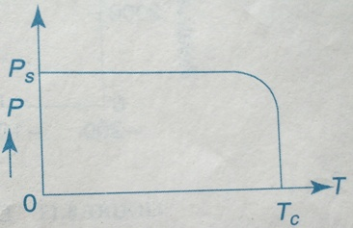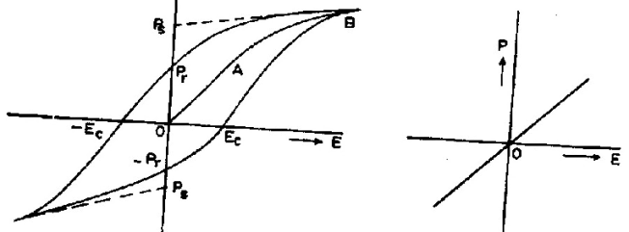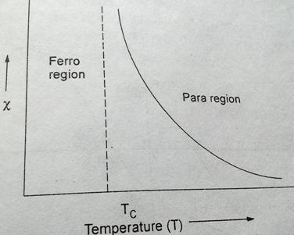

**Ferroelectric Materials and their Applications:**

1. Quartz (SiO2), Lithium Niobate (LiNbO3) and Barium titanate (BaTiO3) etc are used to make transducers and microphones.
2. Thepyroelectric materials such as BaTiO3 , LiNbO3 are used to make very good infra red detectors.
3. BaTiO3 - PbTiO3 ,BaTiO3 - SrTiO3 are used to measure and control temperature , called as posistors.
4. Ferroelectric ceramics are used in the manufacture of capacitors to store electric charge in electrical/electronics circuitry.

**Pyroelectricity:-**

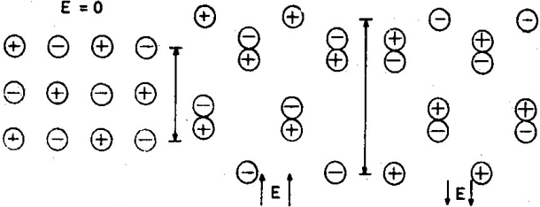Pyroelectric effect is the change in spontaneous polarization when the temperature of specimen is changed.

Pyroelectric coefficient ‘λ’ is defined as the change in polarization per unit temperature change of specimen.

λ= dP / dT.

Change in polarization results in change in external field and hence change on the surface.

*Fig.Displacement of ions under an electric field*

As it is possible to detect a charge of 10-16 Coulomb with a suitable electrometer, temperature changes as small as 10-60c can be measured using the pyroelectric effect.

**Pyroelectric Materials and their Applications:**

1. Thepyroelectric materials such as BaTiO3 , LiNbO3 are used to make very good infra red detectors.
2. Materials such as TGS, NaNO2and PZT ceramics are used in the construction of pyroelectric image tubes.

**Important Applications of Dielectric materials:-**

1. Electrical wires are insulated with a outer jacket of plastic or rubber.

2. In heater coils ceramic beads are used to avoid short circuiting as well as to insulate the outer body from electric current.

3.In electric iron, mica or asbestos insulation is provided to prevent the flow of electric current to the outer body of the iron.

4. In transformers as well as in motor and generator windings varnished cotton is used as insulator.

5. In electricity distribution lines, porcelain structures are used as insulators between points of different potential.

6. Dielectrics are used as energy storage capacitors.

**FORMULAS:**Dielectric constant ℰr = =

ℰr has no units., ℰ0 = 8.85x10-12 F/m

Dipole moment μ= α E

Polarization P= ℰ0 ( ℰr-1) E, P = ℰ0 χe E

Electric Susceptibility, χe  = ℰr -1

Electric displacement D = ℰ0 E + P (or) D = ℰrℰ0E, Units- Coulomb/m2

*Electronic p* polarizability: αe = , Units- F/m2

Ionic polarizability*:-* αi = = [ 1/M +1/m ], Orientational polarizability*:-* αo = =

Total polarization of a material is , PT = Pe + Pi + PO +PS

Internal (or) Lorentz field: Ei  = E + , Clausius- Mosotti relation:- =

**Problem:** A solid elemental dielectric with 3 × 1028 atoms/m3 shows an electronic polarizability of 10−40 F-m2. Assuming

the internal electric field to be a Lorentz field, calculate the dielectric constant of the material.

**Sol:**  Number density of dielectric atoms, N = 3 × 1028/m3 , ectronic polarizability, 𝜶e = 10−40 F-m2

Calculate the dielectric constant, ∈r = ?

𝜶e= ∈0 (∈r – 1)/N

∈r  = + 1

∈r  = (10-40x3 × 1028)/8.85x 10-12) + 1

∈r  = 1.339

**Introduction:**

A bar magnet can be considered as a dipole with a north pole at one end and South Pole at the other. If a magnet is cut into two, two magnets or dipoles are created out of one. This sectioning and creation of dipoles can continue to the atomic level. Therefore, the source of magnetism lies in the basic building block of all the matter i.e. the atom.

Consider electric current flowing through a conductor. When the electrons are flowing through the conductor, a magnetic field is forms around the conductor. A magnetic field is produced whenever an electric charge is in motion. The strength of the field is called the magnetic moment.

Magnetic materials are those which can be easily magnetized as they have permanent magnetic moment in the presence of applied magnetic field. Magnetism arises from the magnetic dipole moments. It is responsible for producing magnetic influence of attraction or repulsion.

**Basic Definitions:**

***Magnet:***A piece of matter, which when suspended freely rests in a particular direction(North-South) and which possesses a net magnetic moment and attracts ferrous bodies towards it, is called a magnet.This property of a magnet is called, *magnetism*.

***Magnetic poles:*** The two points at the ends of a magnet at which magnetism is maximum, are called as magnetic poles.They are of two types, i) North pole ii) South pole

***Magnetic dipole****:*It is a system consisting of two equal and opposite magnetic poles separated by a finite distance (‘2l’metre).

***Magnetic dipole Moment ( μm ) :***It is defined as the product of the pole strength (m) and the distance between the two poles (2l) of the magnet.

i . e . . *μm* = m x 2l ; Units: Ampere – metre2

When an electric current of ‘I’ ampere fows through a cicular wire of one turn having an area of cross section ‘A’ , it is said to have a magnetic moment of , *μm* = I. A ; Units: Ampere – metre2

***Magnetic Flux Density or Magnetic Induction (B):***It is defined as the number of magnetic lines of force passing perpendicularly through a unit area of magnetic material.

i.e., B = magnetic flux / area = Φ / A

Units: Weber/ metre2 or Tesla.

***Magnetic Field:*** The space surrounding the magnet up to which its attracting influence is felt is known as magnetic field***.***

***Magnetic Field Intensity (or) Strength (H):*** The magnetic field intensity at any point in the magnetic field is the force experienced by a unit north pole placed at that point.

Units: Ampere / meter

***MagneticPermeability of free space(μ0):****It is a measure of the amount of* magnetic lines of force passing through air medium . It is defined as the ratio of magnetic induction (B) of a free space to themagnetic field intensity (H).

*i.e****.,*** *μ0 =* B / H, (or) B = *μ0* H

Units:H / m, where *μ*0 is permeability of free space = 4 Π x 10-7 H / m

***MagneticPermeability (μ):****It is a measure of the amount of* magnetic lines of force passing through a material. It is defined as the ratio of magnetic induction (B) in the material to themagnetic field intensity(H).

i.e.,*μ =* B / H (or) B = *μ* H

Units:H / m,

***Relative MagneticPermeability (μr):***It is defined as the ratio ofpermeabilityof the material to permeability of free space.

i.e., *μ*r = *μ / μ*0 (or) *μ* = *μ*0*μ*r

It has no units.

**Intensity of Magnetization (I or M):**

It is the process of converting a non – magnetic material into a magnetic material. The intensity of magnetization (M) is defined as the average magnetic moment present per unit volume.

i.e., I = N

Where, N=no.of atoms per unit volume and average magnetic dipole moment

Units: Ampere / meter

The intensity of magnetization is directly related to the applied field H. i.e., M α H⇒M = χ H

**Magnetic Susceptibility (χm):-**

The magnetic susceptibility of a material is the ratio of the intensity of magnetization produced to the magnetic field intensity which produces the magnetization.

i.e., χm = M / H

It has no units.

***Relation between* B, H and M:**

We know,B = *μ0* H --------(1)

The magnetic Field Intensity (H) and Intensity of Magnetization (I or M), both are having same units and dimensions. Hence, in the presence of magnetic Field Intensity (H),the Magnetic Induction (B can be expressed as ,

**B =*μ*0 ( H + M )** (or) **B =*μ*0 ( I + M )**----------(2)

***Relation betweenμ*r and χ:**

Relative Permeability*, μ*r = *μ / μ*0

*μ*r *=* (B / H ) / ( B / H + M )

*μ*r= H + M / H = 1 + M / H

***μ*r = 1 + χm** (or)  **χm** = ***μ*r - 1**---------(3)

***\*\*\*Classification Of Magnetic Materials :***

All matter respond in one way or the other when subjected to the influence of a magnetic field. The response could be strong or weak, but there is none with zero response ie, there is no matter which is non magnetic in the absolute sense. Depending upon the magnitude and sign of response to the applied field , and also on the basis of effect of temperature on the magnetic properties, all materials are classified broadly under 3 categories.

1. Diamagnetic materials 2. Paramagnetic materials, 3. Ferromagnetic materials

Two more classes of materials have structure very close to ferromagnetic materials but possess quite different magnetic effects. They are i. Anti ferromagnetic materials and ii . Ferri magnetic materials

**1.Diamagnetic materials**:

i. Diamagnetic materials are those which experience a repelling force when brought near the pole of a strong magnet.

ii. In a non uniform magnetic field they are repelled away from stronger parts of the field as shown in fig.1.b.

iii.In the absence of an external magnetic field, the net magnetic dipole moment over each atom or molecule of a

diamagnetic material is zeroas shown in fig.2.

iv. Net magnetic moment exists in the opposite direction of applied magnetic field as shown in fig.3.

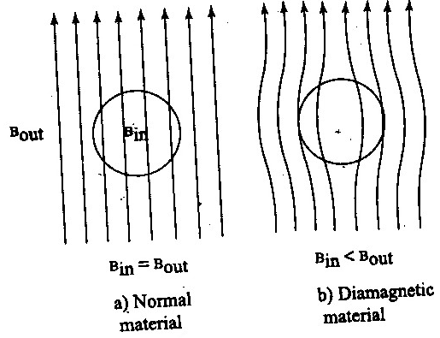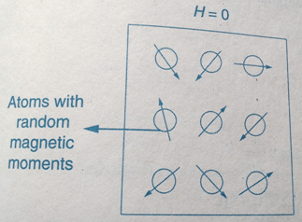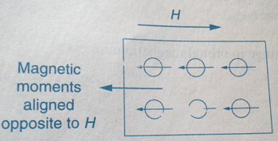

v. No spin alignment is present.

vi. Relative Permeability*,μ*r< 1.vi. Susceptibility, χ is negative

viii. Susceptibilityis independent of temperature T.

ix. Examples: Cu, Ag, Au, Bi, Sb, Pb, NaCl, H2O, Zn and rare gases.

**2. Paramagnetic materials:**

i. Paramagnetic materials are those which experience a feeble attractive force when brought near the pole of a magnet.

ii. They are attracted towards the stronger parts of magnetic fieldas shown in fig.1.

Iii.Due to the spin and orbital motion of the electrons, the atoms of paramagnetic material posses a net intrinsic permanent

moment.

iv. Net magnetic moment exists in the direction of applied magnetic field.

v. All spins (or) magnetic moments are randomly oriented as shown in fig.2.

vi. Relative Permeability *, μ*r>1.vii. Susceptibility χ is positive and low for these materials.

viii. The susceptibility is inversely proportional to the temperature T. This behavior is shown in fig.3&4.

i.e., χ α 1/T , χ = C / T where C is Curie’s constant.

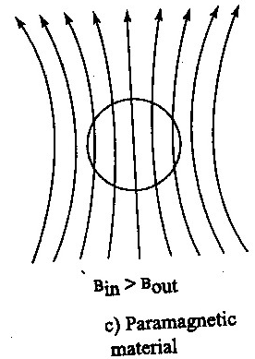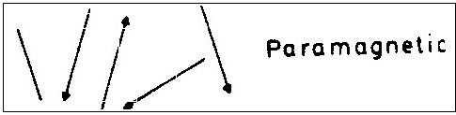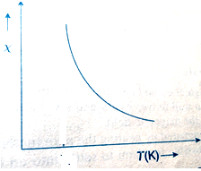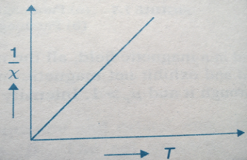

ix. Below superconducting transition temperatures, these materials exhibit the Para magnetism.

x. Examples: Al, Mn, Pt, Na, CuCl2, O2, crown glass etc.

**3.Ferromagnetic Materials:**

i. Ferromagnetic materials are those which experience a very strong attractive force when brought near the pole of a magnet. ii. These materials, apart from getting magnetized parallel to the direction of the applied field, will continue to retain the

magnetic property even after the magnetizing field removed.

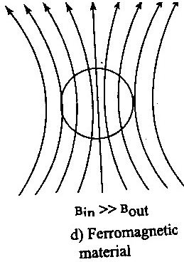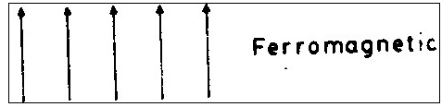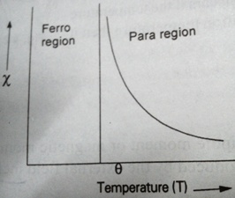

iii. The atoms of ferromagnetic materials also have a net intrinsic magnetic dipole moment which is due to the spin of the

electrons.

iv. Large net magnetic moment exists in the direction of applied magnetic field.

v. All spins (or) magnetic moments are randomly oriented as shown in fig.2.

vi. Relative Permeability*,μ*r>>1.vii. Susceptibility (χ) is always positive and high.

viii. Susceptibility,χ is inversely proportional to the temperature (T).

i.e., χ = C / (T- θ) ( only in paramagnetic region i.e., T > θ)θ is Curie’s temperature.

ix. When the temperature of the material is greater than its Curie temperature then it converts into paramagnetic material.

x. Examples: Fe, Ni, Co, MnO.

1. **Anti ferromagneticmaterials :**

i. These are the ferromagnetic materials in which equal no of opposite spins with same magnitude such that the

orientation of neighboring spins is in antiparallel manner are present as shown ion fig.1.

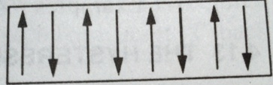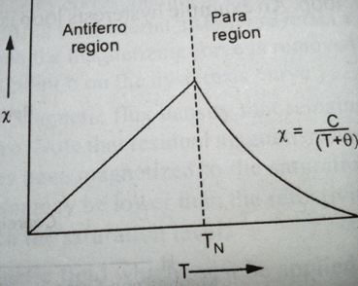

ii. Spin alignment is in antiparallel manner as shown in fig.1

iii. Net magnetic moment exists in the direction of applied magnetic field.

iv. Relative Permeability *, μ*r>1.

v. Susceptibility is low and positive.

vi. Susceptibility is inversely proportional to the temperature.

i.e., χ=C /(T+θ) , when T> TN ( Neel’s température)

vii. The temperature at which anti ferromagnetic material converts into paramagnetic material is known as Neel’s

temperature. This behavior is shown in fig.2.

vii. Examples: FeO, MnO, Cr2O3.

**5.Ferrimagnetic materials (Ferrites):**

i. These are the ferromagnetic materials in which equal no of opposite spins with different magnitudes such that the

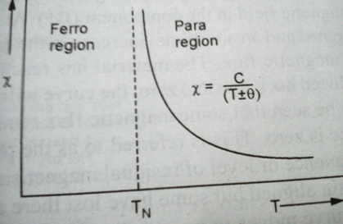orientation of neighbouring spins is in antiparallel manner are present.

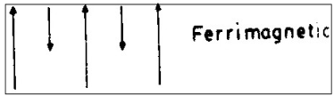

ii. Spin alignment is in antiparallel manner as shown in fig.1.

iii. Large net magnetic moment exists in the direction of applied magnetic field.

iv. Relative Permeability*,μ*r>>1.v. Susceptibility is positive and high

vi.Susceptibilityis inversely proportional to temperature.

i.e., χ=C /(T ± θ) , when T> TN ( Neel’s temperature)

vii. The variation of Susceptibility withtemperature as shown in fig.2.

viii. Ferrites are the best examples of ferrimagnetic materials

ix. Examples : ZnFe2O4, CuFe2O4, Fe3O4

**\*\*\*\*\*Domain theory of Ferromagnetism:**

A ferromagnetic material such as iron does not have any magnetization in the absence of an external field. But according toWeiss theory, the molecular magnets in the ferromagnetic material are said to be aligned in such a way that, they exhibit a magnetization even in the absence of an external magnetic field. This is called spontaneous magnetization. It should have some internal magnetization due to quantum exchange energy.

Thus according toWeiss hypothesis, a single crystal of ferromagnetic material is divided into large number of small regions called domains(≈ 10-6 m or larger).These domains have spontaneous magnetization due to the parallel alignment of spin magnetic moments in each domain.But the direction of spontaneous magnetization varies from domain to domain. The resultant magnetization may be zero or nearly zero as shown in fig.a.

When an external magnetic field is applied, then themagnetization occurs in the specimen by two ways.

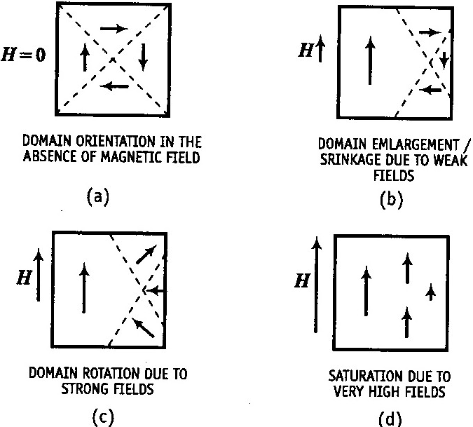They are,

1. By the motion of domain walls.

2. By the rotation of domain walls.

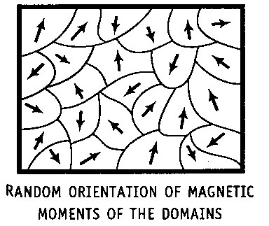

*1. By the motion of domain walls:*

The movement of domain walls takes place in weak magnetic fields. Due to this weak magnetic field applied to the

specimen the magnetic moment increases and hence the boundaries of domains are

displaced. So that the volume of domains changes as shown in fig.b.

*2. By the rotation of domain walls:*

The rotation of domain walls takes place in strong magnetic fields. When the external magnetic field is high(strong) then

the magnetization changes by means of rotation of the direction of magnetization towards the direction of applied field as

shown in fig.c & d.

**\*\*\*Hysteresis curve (study of B-H curve):**

When a ferromagnetic material is made to undergo through a cycle of magnetization,the variation of magnetic induction(B) with respect to appliedmagnetic field intensity (H) can be represented by a closed curve (or) loop as shown in fig.1. It refers to the lagging of B behind H is known as hysteresis curve (or) B-H curve. The closed curve ‘ abcdefa ‘ which a cycle of magnetization of specimen is known as hysteresis curve of the specimen.

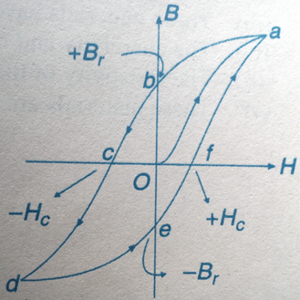The point ‘O ‘ represents an initially unmagnetized specimen and a zero magnetic field intensity.

As H is increased, B also increases but not uniformly and a point such as ‘a’ is reached. If H is now decreased, B also decreases but following a path ‘ab’. Thus, B lags behind H. When H becomes zero, B still has a value equal to ‘Ob’. This magnetic flux density remaining in the specimen even in the absence of external field is called the ‘residual magnetism’. The power of this magnetism is called the ‘retentivity’ or ‘remanence’ of the specimen. Thus, Br is a measure of the magnetic fluxremaining in the specimen when the ‘H’ is removed.

If the magnetic field intensity (H) is now increased in the reverse direction, the value of B further decreases, still lagging behind and becomes zero when H has a value equal to Oc. This value of the magnetic intensity is called the coercive force or coercivity of the specimen.Thus, Hc is

a measure of the magneticintensity required to destroy the residual magnetism of the specimen.

As H is increased beyond ‘Oc’, the specimen is magnetized in the opposite direction, and a point such as d is reached. By taking H back from its negative maximum value through zero nto its original positive maximum value, a similar curve’ defa’ is obtained. At points b band e where the specimen is magnetized in the absence of external field, it is said to be a ‘ permanent magnet’.

It is thus found that the magnetic induction (B) always lags behind themagnetic field intensity (H). The lagging of B behind H is called ‘hysteresis’.

**TEXT BOOKS: 1. Engineering Physics, B.K. Pandey, S. Chaturvedi - CengageLearing. 2. Halliday and Resnick, Physics - Wiley. 3. A textbook of Engineering Physics, Dr. M. N. Avadhanulu, Dr. P.G. Kshirsagar - S. Chand**

**REFERENCES: 1. Richard Robinett, Quantum Mechanics 2. J. Singh, Semiconductor Optoelectronics: Physics and Technology, Mc Graw-Hill inc.**